
Symbiosis Institute of Technology, Pune
Faculty of Engineering
CSE- Academic Year 2026-27
Java Programming – Lab Batch 2024-28
Lab Assignment No: - 30
Name of Student: Sanika Botre
PRN No.: 25070122063
Batch: 2025-29
Class: CSE A-2
Academic Year & Semester: 2026 & 3rd Semester
Date of Submission
Title of Assignment: Write a JSP application to demonstrate CRUD operations.
Learning Objectives: To implement Create, Read, Update, and Delete operations using JSP and a database.
Theory:
CRUD stands for Create, Read, Update, and Delete, which represent the four basic database operations performed in web applications. JSP works together with Servlets and JDBC to implement these operations. Users interact with HTML forms created using JSP, while JDBC executes SQL statements to manipulate database records. INSERT adds new records, SELECT retrieves information, UPDATE modifies existing data, and DELETE removes unwanted records. Proper validation, exception handling, and session management improve application reliability and security. JSP CRUD applications are widely used in employee management systems, online shopping portals, hospital management systems, banking applications, and other enterprise software.

Practice questions
1. Create a JSP-based application to add, update, delete, and view employee details
Code:
<%@ page import="java.sql.*" %>
<html>
<body>

<h2>Employee Management System</h2>

<%
String action = request.getParameter("action");

try {
Class.forName("com.mysql.cj.jdbc.Driver");

try (Connection con = DriverManager.getConnection(
"jdbc:mysql://localhost:3306/studentdb", "root", "Sanika23@")) {

if ("Add".equals(action)) {
PreparedStatement ps = con.prepareStatement(
"insert into employee values(?,?,?,?)");

ps.setInt(1, Integer.parseInt(request.getParameter("emp_id")));
ps.setString(2, request.getParameter("name"));
ps.setString(3, request.getParameter("department"));
ps.setDouble(4, Double.parseDouble(request.getParameter("salary")));

ps.executeUpdate();
ps.close();
out.println("Employee added successfully!");
}

if ("Update".equals(action)) {
PreparedStatement ps = con.prepareStatement(
"update employee set name=?, department=?, salary=? where emp_id=?");

ps.setString(1, request.getParameter("name"));
ps.setString(2, request.getParameter("department"));
ps.setDouble(3, Double.parseDouble(request.getParameter("salary")));
ps.setInt(4, Integer.parseInt(request.getParameter("emp_id")));

int rows = ps.executeUpdate();
ps.close();

if (rows > 0)
out.println("Employee updated successfully!");
else
out.println("Employee ID not found!");
}

if ("Delete".equals(action)) {
PreparedStatement ps = con.prepareStatement(
"delete from employee where emp_id=?");

ps.setInt(1, Integer.parseInt(request.getParameter("emp_id")));

int rows = ps.executeUpdate();
ps.close();

if (rows > 0)
out.println("Employee deleted successfully!");
else
out.println("Employee ID not found!");
}
}
} catch (Exception e) {
out.println("Error: " + e.getMessage());
}
%>

<h3>Enter Employee Details</h3>

<form method="post">
Employee ID:
<input type="number" name="emp_id" required><br><br>

Name:
<input type="text" name="name" required><br><br>

Department:
<input type="text" name="department" required><br><br>

Salary:
<input type="number" step="0.01" name="salary" required><br><br>

<button type="submit" name="action" value="Add">Add</button>
<button type="submit" name="action" value="Update">Update</button>
<button type="submit" name="action" value="Delete">Delete</button>
</form>

<h3>Employee Records</h3>

<table border="1" cellpadding="8">
<tr>
<th>ID</th>
<th>Name</th>
<th>Department</th>
<th>Salary</th>
</tr>

<%
try {
Class.forName("com.mysql.cj.jdbc.Driver");

try (Connection con = DriverManager.getConnection(
"jdbc:mysql://localhost:3306/studentdb", "root", "Sanika23@");
Statement st = con.createStatement();
ResultSet rs = st.executeQuery("select * from employee")) {

while (rs.next()) {
%>
<tr>
<td><%= rs.getInt("emp_id") %></td>
<td><%= rs.getString("name") %></td>
<td><%= rs.getString("department") %></td>
<td><%= rs.getDouble("salary") %></td>
</tr>
<%
}
}
} catch (Exception e) {
out.println("<tr><td colspan='4'>Error: " + e.getMessage() + "</td></tr>");
}
%>

</table>

</body>
</html>

Output:
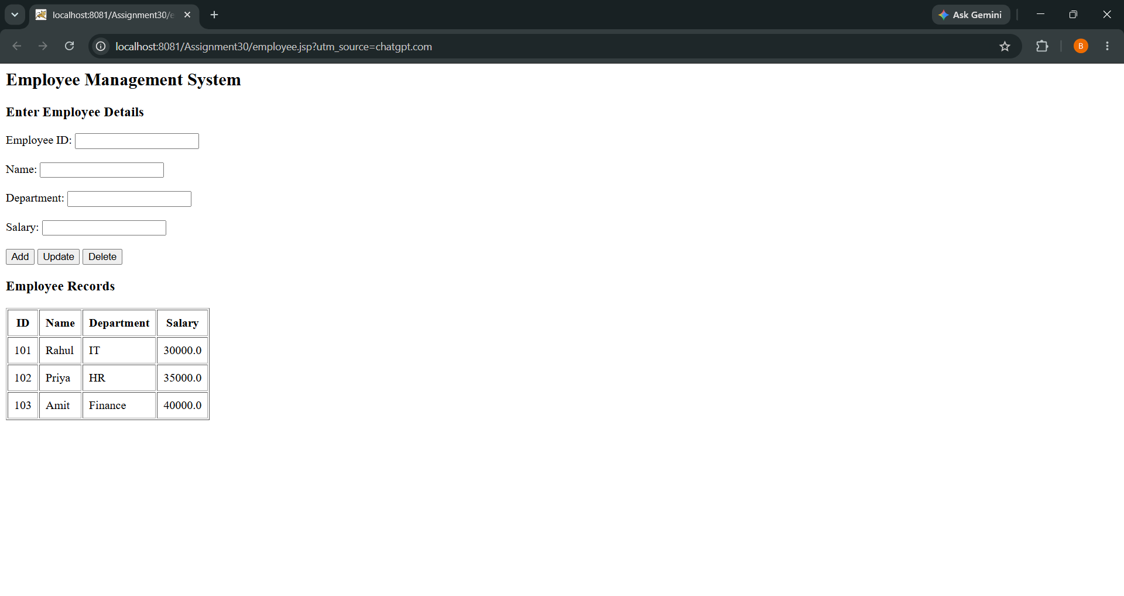

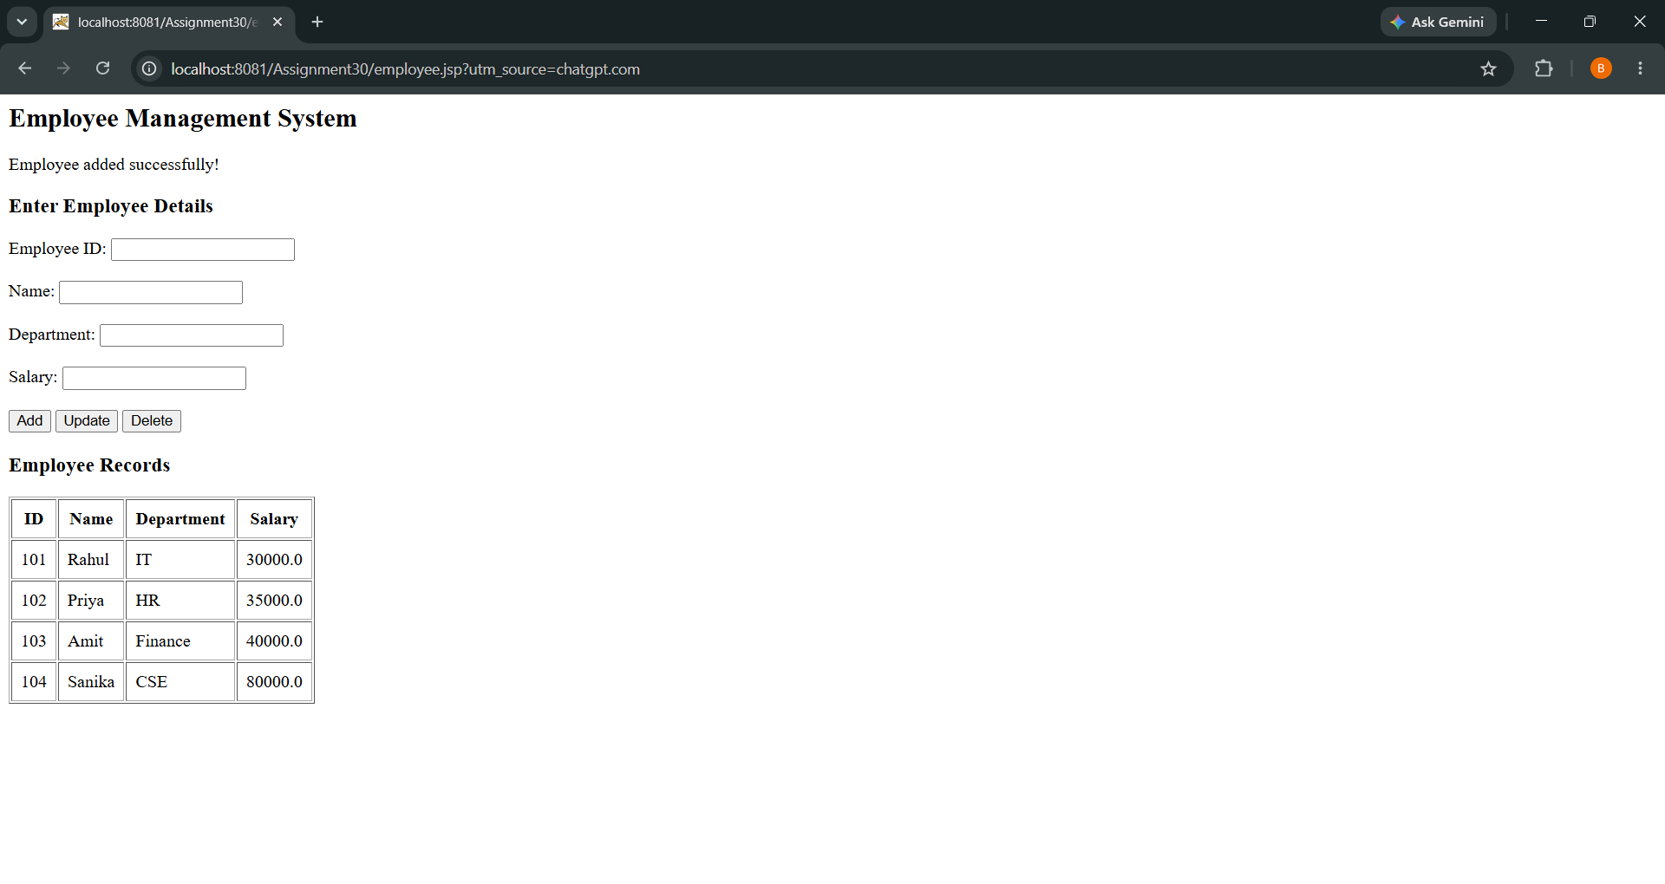
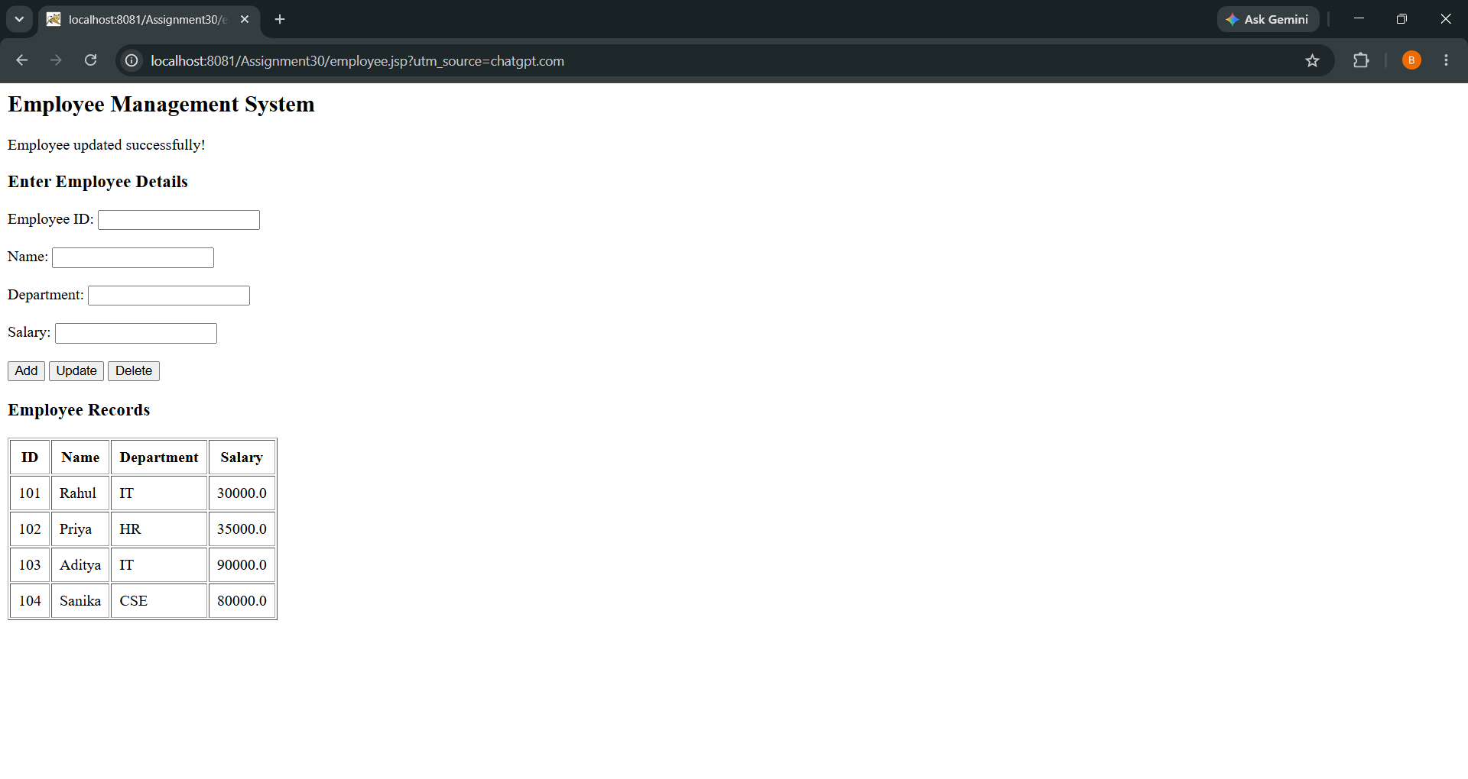

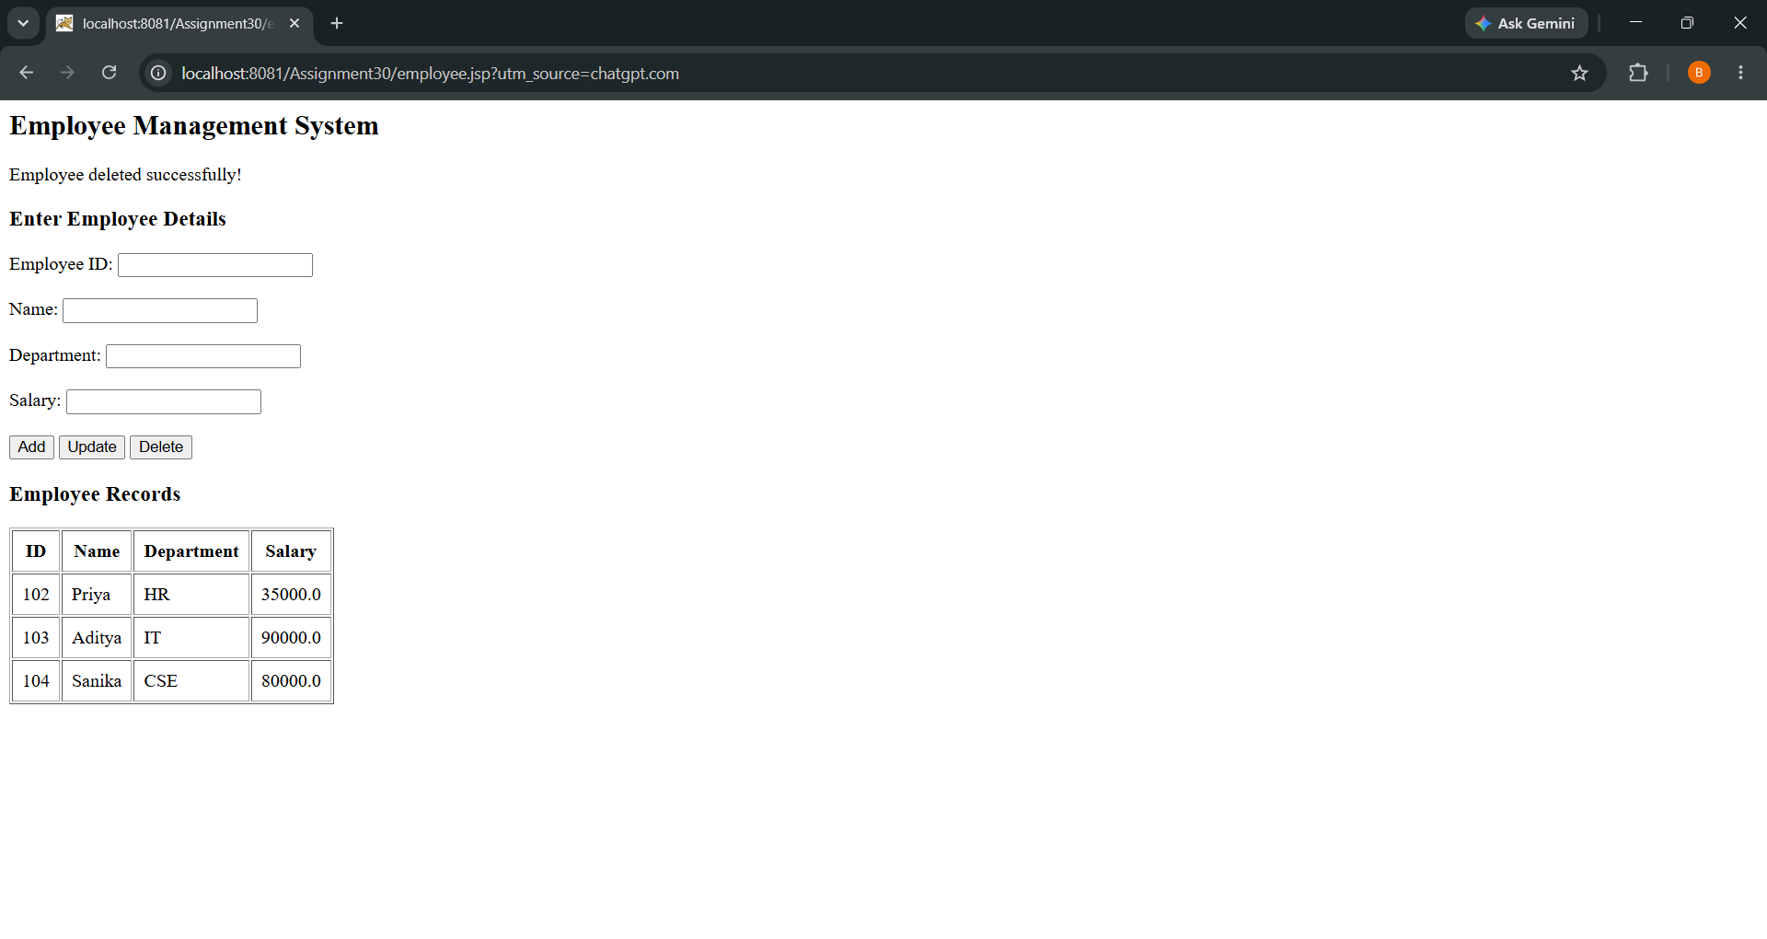
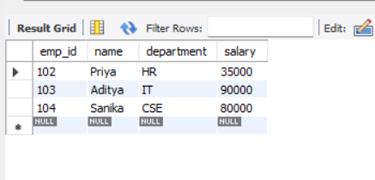

2. Create a JSP-based application to manage patient records using CRUD operations. Include fields such as patient ID, name, age, disease, and treatment status.
Code

<%@ page import="java.sql.*" %>
<html>
<head>
<title>Patient Management System</title>
</head>
<body>

<h2>Patient Management System</h2>

<%
String action = request.getParameter("action");

try {
Class.forName("com.mysql.cj.jdbc.Driver");

try (Connection con = DriverManager.getConnection(
"jdbc:mysql://localhost:3306/studentdb", "root", "Sanika23@")) {

if ("Add".equals(action)) {
PreparedStatement ps = con.prepareStatement(
"insert into patient values(?,?,?,?,?)");

ps.setInt(1, Integer.parseInt(request.getParameter("patient_id")));
ps.setString(2, request.getParameter("name"));
ps.setInt(3, Integer.parseInt(request.getParameter("age")));
ps.setString(4, request.getParameter("disease"));
ps.setString(5, request.getParameter("treatment_status"));

ps.executeUpdate();
ps.close();
out.println("Patient added successfully!");
}

if ("Update".equals(action)) {
PreparedStatement ps = con.prepareStatement(
"update patient set name=?, age=?, disease=?, treatment_status=? where patient_id=?");

ps.setString(1, request.getParameter("name"));
ps.setInt(2, Integer.parseInt(request.getParameter("age")));
ps.setString(3, request.getParameter("disease"));
ps.setString(4, request.getParameter("treatment_status"));
ps.setInt(5, Integer.parseInt(request.getParameter("patient_id")));

int rows = ps.executeUpdate();
ps.close();

if (rows > 0)
out.println("Patient updated successfully!");
else
out.println("Patient ID not found!");
}

if ("Delete".equals(action)) {
PreparedStatement ps = con.prepareStatement(
"delete from patient where patient_id=?");

ps.setInt(1, Integer.parseInt(request.getParameter("patient_id")));

int rows = ps.executeUpdate();
ps.close();

if (rows > 0)
out.println("Patient deleted successfully!");
else
out.println("Patient ID not found!");
}
}
} catch (Exception e) {
out.println("Error: " + e.getMessage());
}
%>

<h3>Enter Patient Details</h3>

<form method="post">
Patient ID:
<input type="number" name="patient_id" required><br><br>

Name:
<input type="text" name="name" required><br><br>

Age:
<input type="number" name="age" min="0" required><br><br>

Disease:
<input type="text" name="disease" required><br><br>

Treatment Status:
<select name="treatment_status" required>
<option value="Under Treatment">Under Treatment</option>
<option value="Recovered">Recovered</option>
<option value="Discharged">Discharged</option>
</select><br><br>

<button type="submit" name="action" value="Add">Add</button>
<button type="submit" name="action" value="Update">Update</button>
<button type="submit" name="action" value="Delete">Delete</button>
</form>

<h3>Patient Records</h3>

<table border="1" cellpadding="8">
<tr>
<th>Patient ID</th>
<th>Name</th>
<th>Age</th>
<th>Disease</th>
<th>Treatment Status</th>
</tr>

<%
try {
Class.forName("com.mysql.cj.jdbc.Driver");

try (Connection con = DriverManager.getConnection(
"jdbc:mysql://localhost:3306/studentdb", "root", "Sanika23@");
Statement st = con.createStatement();
ResultSet rs = st.executeQuery("select * from patient")) {

while (rs.next()) {
%>
<tr>
<td><%= rs.getInt("patient_id") %></td>
<td><%= rs.getString("name") %></td>
<td><%= rs.getInt("age") %></td>
<td><%= rs.getString("disease") %></td>
<td><%= rs.getString("treatment_status") %></td>
</tr>
<%
}
}
} catch (Exception e) {
out.println("<tr><td colspan='5'>Error: " + e.getMessage() + "</td></tr>");
}
%>

</table>

</body>
</html>

Output:

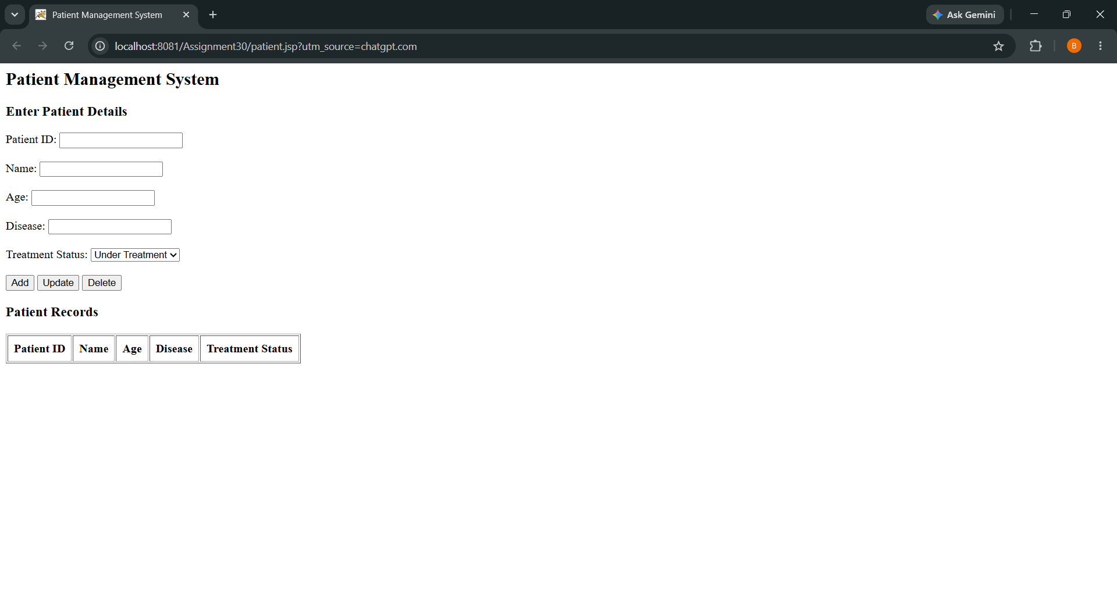

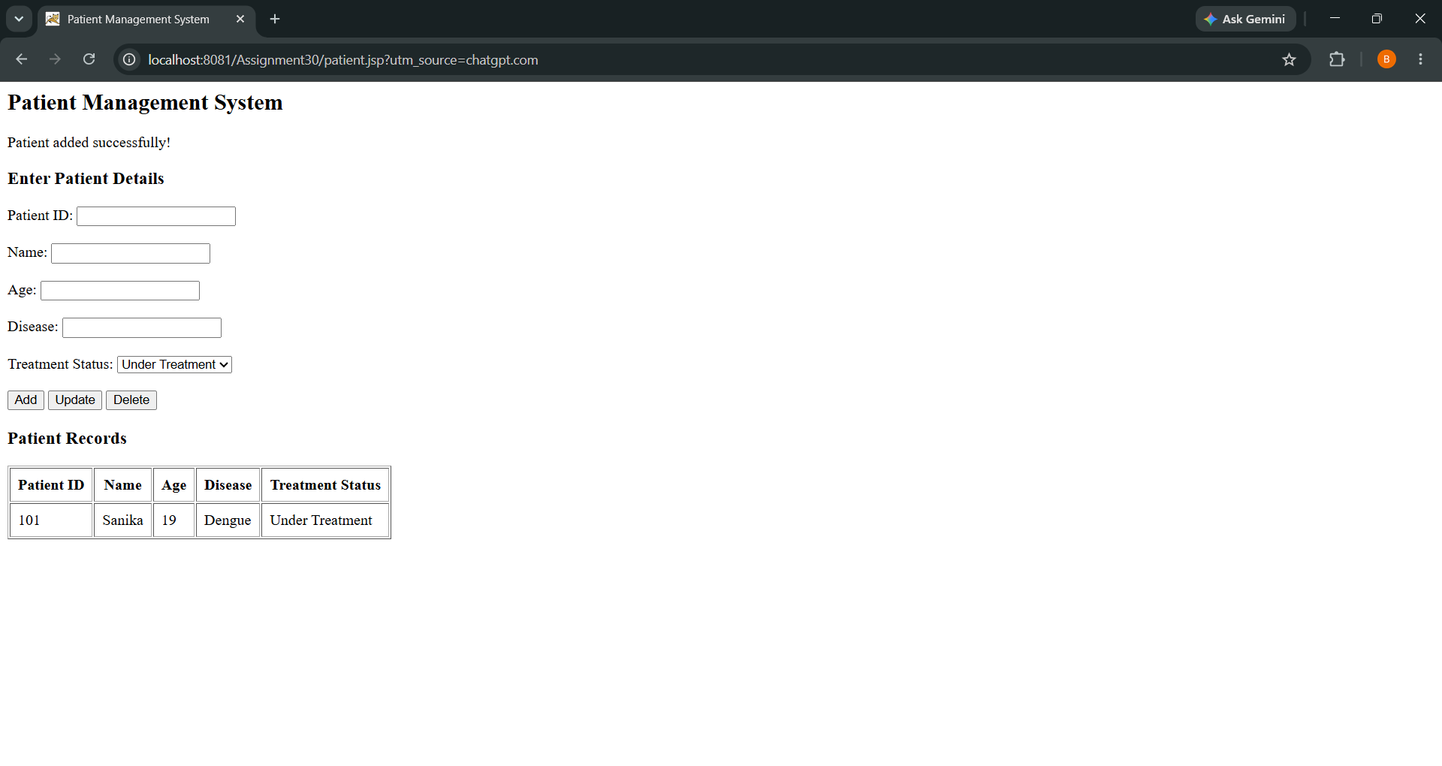
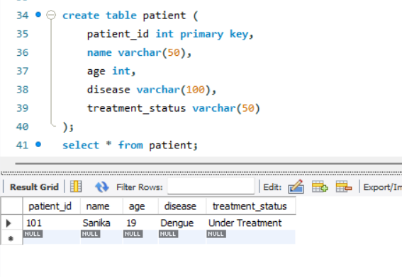

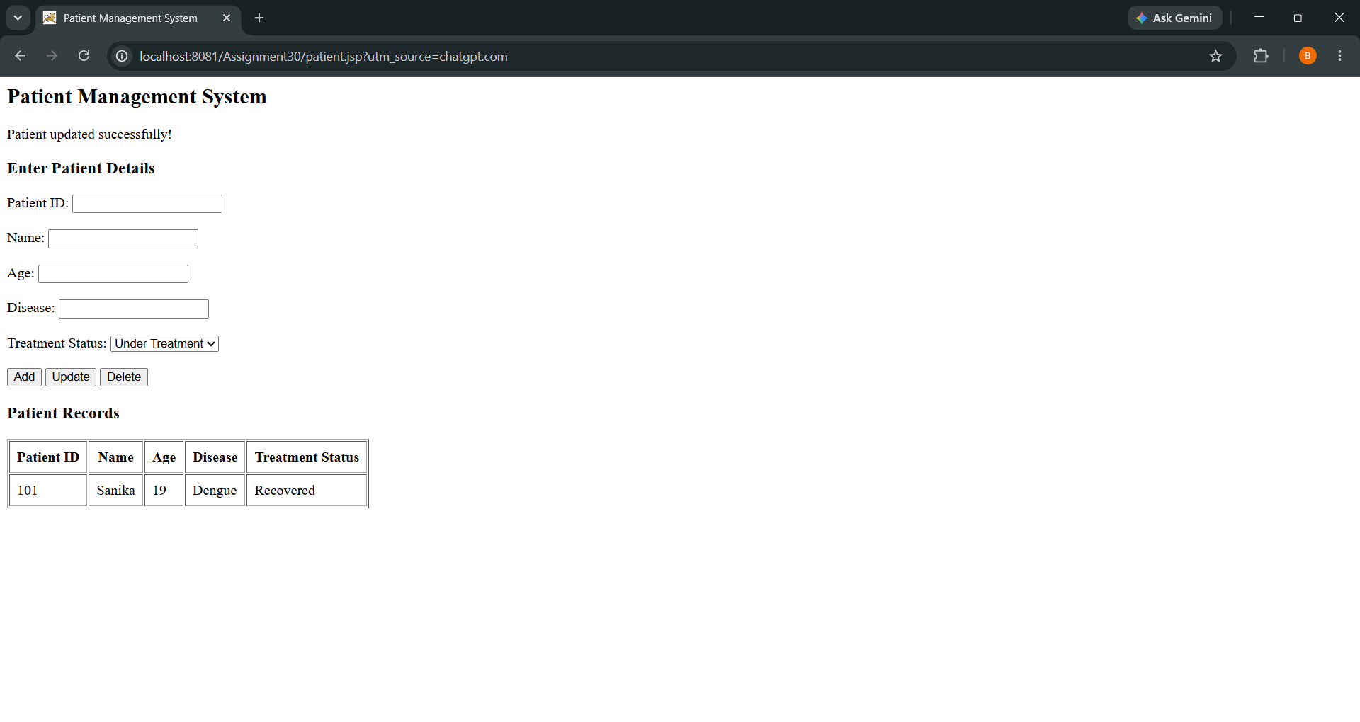
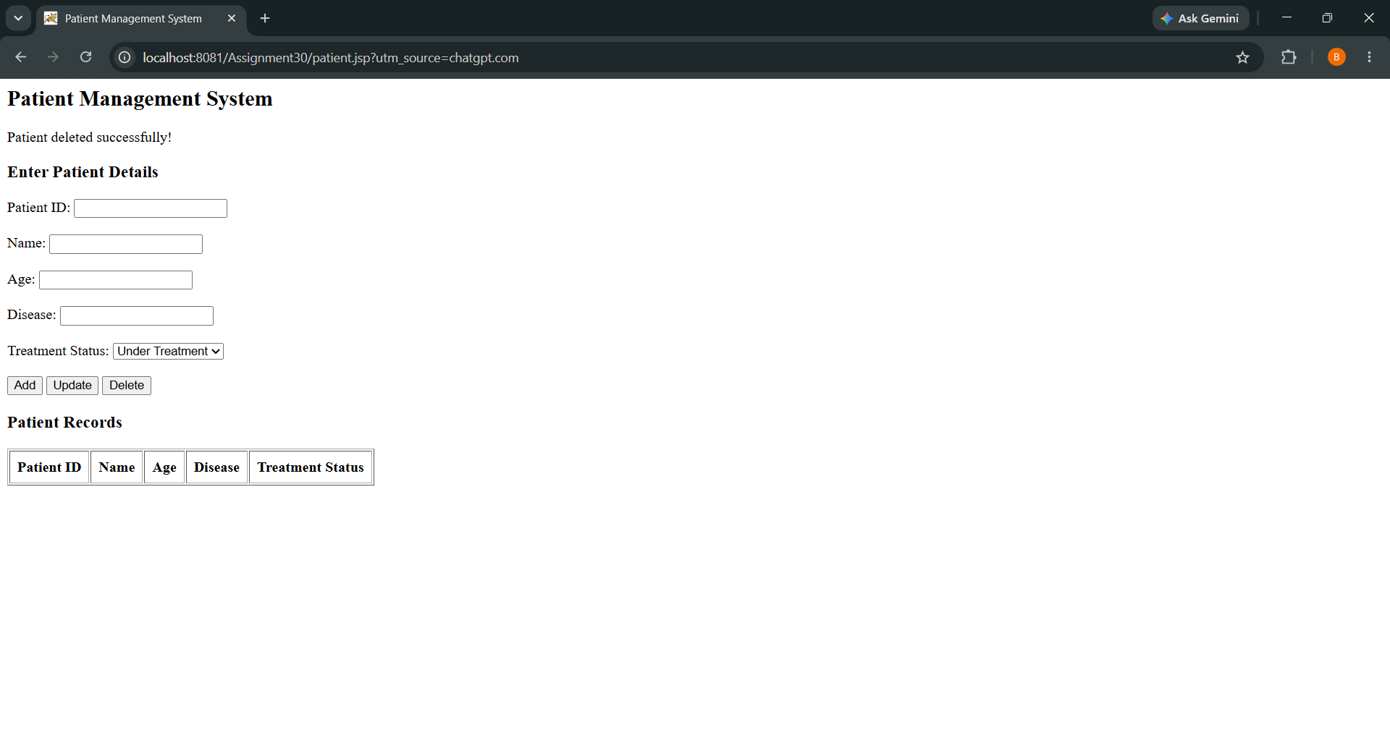

Conclusion
Thus, the JSP-based Patient Management System was successfully developed using Java Server Pages and MySQL. The application performs CRUD operations to add, view, update, and delete patient records. It manages patient details such as patient ID, name, age, disease, and treatment status.

